Augmented Reality: A class of displays on the reality - virtuality continuum

**ABSTRACT**

• Mixed Reality are defined by different display concepts (real objects and virtual objects are opposite).The primary factors to distinguish unique Mixed Reality display systems is that comparing with underlying scene, viewing methods, the observer's references and then by three dimensional framework.

• The major aim of taxonomy is to clarify academic issues and offer a framework for research.

**1. INTRODUCTION**

The report is aimed to review some definitions of the term AR, classify the relationships between AR and technologies which we refer to as MR ,and propose some vital factors of classification. This paper is limited strictly to visual displays.

In Section 2.we present our view of how AR can be regarded in terms of a continuum relating purely virtual environments to purely real environments.

In Section 3 we review the two principal manifestations of AR display systems: head-mounted see-through and monitor-based video AR displays.

In Section 4 we extend the discussion to MR systems in general, and provide a list of seven classes of MR displays. We also provide a table highlighting basic differences between these.

Finally, in Section 5 we propose a formal taxonomy of mixed real and virtual worlds. It is important to note that our discussion in this paper is limited strictly to visual displays.

**2. REALITY-VIRTUALITY CONTINUUM**

• AR and VR are relevant and that it is quite valid to consider the two concepts together. The common view of VR environment is that observer is totally immersed in a completely synthetic world(unreal).

• We viewed RV as a continuum:

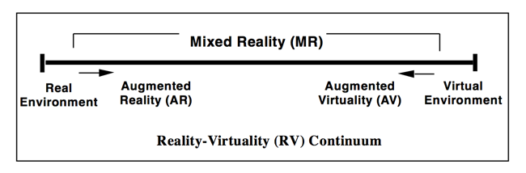

**3. TWO CATEGORIES OF AUGMENTED REALITY DISPLAYS**

The broad definition of Augmented Reality is that augmenting natural feedback to the operator with simulated cues.

**3.1 "See-through" AR displays**

The class of displays could directly see the world surrounding the observer by the display medium. Most common application is using mirrors to superimpose computer generated graphics optically onto directly viewed real-world scenes. In some areas ,especially military, this kind of displays was already a mature technology. But we also are exploring wider applications. With the adent of optical ST displays, the requirements of accurate and precise was raised.

**3.2 Monitor based AR displays**

The term monitor-based(non-immersive),AR to refer to display systems where computer generated images are either nalogically or digitally overlaid onto live or stored video images.

**4.THE GENERAL CASE: MIXED REALITY ENVIRONMENTS**

In this section we discuss how Augmented Reality relates to other classes of Mixed Reality displays.

1.Monitor-based (non-immersive) AR displays, upon which computer graphic (CG) images are overlaid

2.Same as 1, but using immersive HMD-based displays, rather than WoW monitors.

3.Same as 1, but using immersive HMD-based displays, rather than WoW monitors.

4.HMD-based AR systems, incorporating optical see-through (ST).

5.Monitor-based AV systems, with CG world substratum, employing superimposed video reality

6. Immersive or partially immersive (e.g. large screen display) AV systems, with CG substratum, employing superimposed video or texture mapped reality 7

.Partially immersive AV systems, which allow additional real-object interactions, such as 'reaching in' and 'grabbing' with one's own (real) hand.

**5. A TAXONOMY FOR MIXING REAL AND VIRTUAL WORLDS**

We need to create a taxonomy to classify mixing real and virtual worlds. There are three disciplines:

R

• **Reality**: that is, some environments are primarily virtual, in the sense that they have been createdartificially, by computer, while others are primarily real

• **Immersion**: that is, virtual and real environments can each be displayed without the need for the

observer to be completely immersed within them.

• **Directness**: that is, whether primary world objects are viewed directly or by means of some electronic synthesis process.

**5.1 Extent of world knowledge**

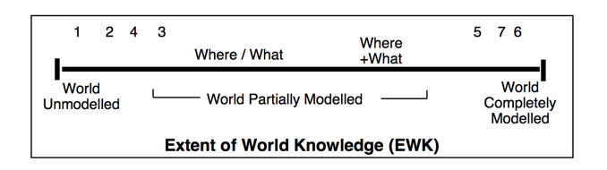

**5.2 Reproduction Fidelity**

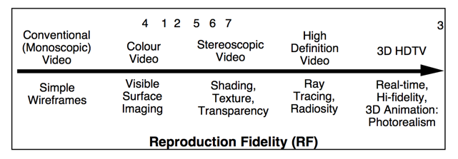

**5.3 Extent of Presence Metaphor**

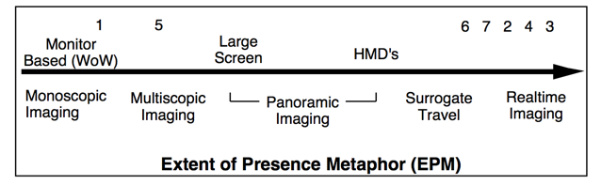

**6.CONCLUSION**

We have probed deeper, and posited some of the essential factors which distinguish different Mixed Reality display systems from each other.